**DAV HZL SR. SEC. SCHOOL, DARIBA**

**TENTATIVE CO-CURRICULAR ACTIVITIES 2024-25**

|  |  |  |
| --- | --- | --- |
| **Date** | **Class** | **Activity (Events)** |
| 06/04/2024 | III TO V | Cinematic Odyssey: Arya Samaj Chronicles |
| VI TO VIII | Narrative Alchemy: Crafting English Tales |
| IX TO XII | Lens Enchantment: Interclass Cinematic Journey |
| 20/04/2024 | III TO V | Soliloquy Symphony: Mastering English Monologues |
| VI TO VIII | Dramatic Flourish: Theatrical Skits in English |
| IX TO XII | Electoral Insights: Interclass PowerPoint Showdown |
| 04/05/2024 | III TO V | Artistry Unleashed: Collage Creation Extravaganza |
| VI TO VIII | Sculpting Stories: From Clay to Chronicle |
| IX TO XI | Pixel Perfection: Design Delights with Photoshop |
| 05/07/2024 | III TO VIII | Green Horizon: Plantation Expedition |
| 06/07/2024 | III TO V | Calligraphy |
| VI TO X | Echoes of Ecology: English Environmental Orations |
| 11/07/2024 | III TO XII | Leadership Unveiled: Investiture Spectacular |
| 20/07/2024 | III TO V | Lexical Showdown: Spellbinding Spell Bee |
| VI TO VII | Verbal Voyage: Vocabulary Ventures |
| IX TO XI | Enlightening Discourse: TED Talk Showdown |
| 03/08/2024 | III TO V | Culinary Chronicles: Fireside Cooking & Artistry |
| VI TO IX | Taste Temptations: Culinary Competition |
| 17/08/2024 | III TO VIII | Cultural Kaleidoscope: Rangoli, Rakhi& Arya Samaj Quizzes |
| 31/08/2024 | III TO V | Social Science Showdown: Quiz Quest |
| VII TO X | Parliamentary Prowess: Youth Debate Showdown |
| 06/09/2024 | III TO V | Hindi Heritage: Crafting Original Stories & Poems |
| VI TO VII | Hindi Heritage: Crafting Original Poems |
| VIII TO X | Declamatory Divinity: Hindi Oratory Odyssey |
| 05/10/2024 | III TO V | Blogosphere Brilliance: Crafting Digital Chronicles |
| VI TO VII | Wall Wonders: Mural Masterpieces |
| VIII | Wonders on earthen plates |
| 19/10/2024 | III TO V | Moral Mosaic: Hindi Skits on Values |
| VI TO IX | Theatrical Tribute: Great Personality Dramatizations |
| 08/11/2024 | III TO V | Melodic Medley: Songster Showdown |
| VI TO IX | Devotional Delights: Bhajan Bliss |
| 23/11/2024` | III TO V | Innovation Illuminated: Inventors' Showcase |
| VI TO VII | Journey of a Dreamer;Biography |
| VIII TO IX Sci. | Scientific Sorcery: Enchanting Science Magic |
| 07/12/2024 | III TO V | Literary Legacy: Bookmark Bonanza |
| VI TO VIII | Informative Imprints: Brochure Brilliance |
| 21/12/2024 | III TO IX | Math Marvels: Exploring Fun & Practical Mathematics |
| 18/01/2025 | III TO VII | Patriotic Penmanship: Slogan Sketching & Doodling |
| 31/01/2025 | III TO V | Resourceful Innovation: Waste Material Wonders & Presentations |

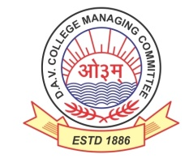

DAV HZL Sr. Sec. School dariba

rajsamand (raj.)

DAV HZL Sr. Sec. School dariba, rajsamand(raj.)

Split-up Syllabus

Class- III

Split-up Syllabus & Activities

for the session

2024-25

Class-IX

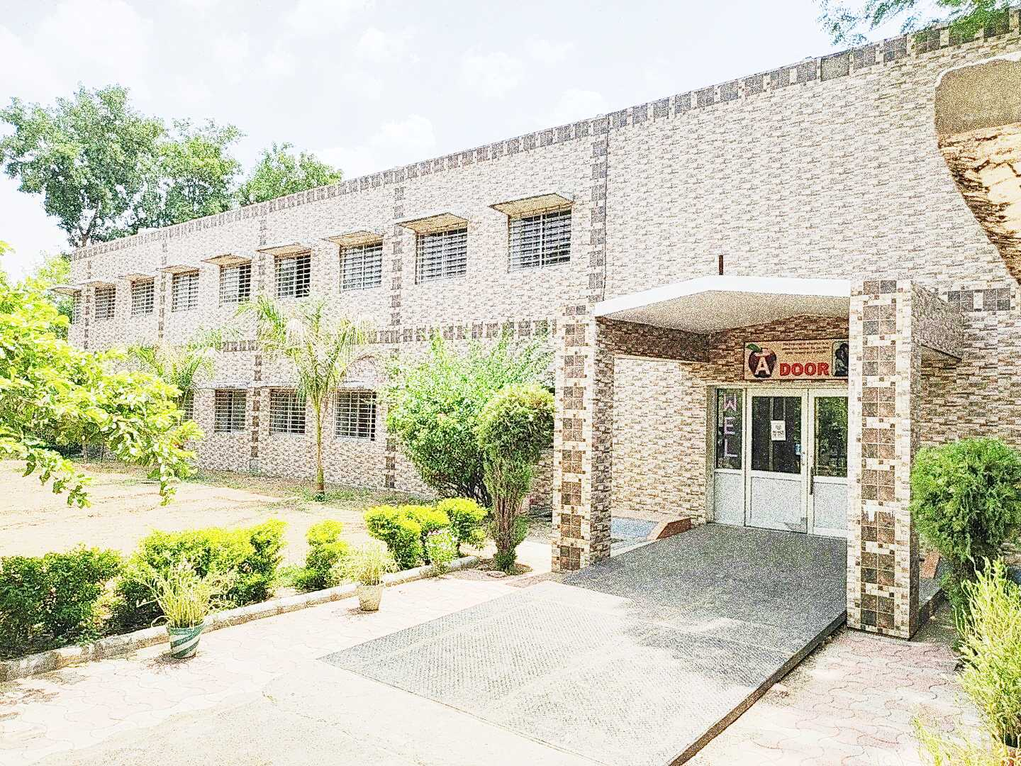

Address : Rajpura-Dariba, Distt. – Rajsamand (Raj.) 313211

Contact : (02952)265130 Email : davhzl_dariba@yahoo.com Website : http://www.davhzldariba.in

| **Subject** | | **PT- I** | **PT- II** |
| --- | --- | --- | --- |
| English | | The Fun They Had, The Road Not Taken, The Lost Child, Tenses, Diary Entry | The Sound of Music, Wind, Adventure of Toto, Modals, Writing a descriptive paragraph (person/event/situation) |
| Hindi | | गद्य पाठ 1- दो बैलों की कथा पद्म पाठ 9- कबीर सबद साखियाँ, व्याकरण-अलंकार(अनुप्रास)- अपठित गद्यांश | व्याकरण उपसर्ग, प्रत्यय ,अपठित काव्यांश गद्य पाठ-2 ल्हासा की ओर काव्य पाठ-2 वाख |
| Maths | | Chapter-1 and 2 | Chapter-3,4,5 |
| Sci | Che. | Chapter-1 | Chapter-2 |
| Phy. | Chapter-7 | Chapter-8 |
| Bio. | Chapter-5 | Chapter-6 |
| S.St. | Eco. | - | Chapter- 1 |
| His. | Chapter- 1 | - |
| Geo. | Chapter- 1 | - |
| Civics | - | Chapter- 1 |
| ICT | | Unit-3 | Unit-6 |

| **Subject** | | **Mid Term** |
| --- | --- | --- |
| English | | The Fun They Had, The Road Not Taken, The Sound OF Music, Wind, The Little Girl, Rain on The Roof, A Truly Beautiful Mind, The Lake Isle of Innisfree, , The Lost Child, The Adventure of Toto,Iswaran the Storyteller, In the Kingdom of Fools, ,Tenses,Diary entry, Modals, Descriptive Paragraph writing (Person,Place,Thing), Determiners |
| Hindi | | व्याकरण-अपठित गद्यांश, अपठित काव्यांश, उपसर्ग, प्रत्यय, अलंकार, समास अर्थ के आधार पर वाक्य भेद  गद्य खंड पाठ 1, 2, 3 ,काव्य खंड पाठ 1,2,3 कृतिका पाठ-1 इस जल प्रलय में  पाठ-। दो बैलों की कथा, ल्हासा की ओर  पाठ 3 उपभोक्तावाद की संस्कृति काव्य , पाठ-1 साखिया सबद, वाख , सवैये लेखन खंड – अनुच्छेद लेखन ,औपचारिक ओर अनौपचारिक पत्र ई-मेल संवाद , सूचना , लघु-कथा |
| Maths | | Chapter-1,2,3,4,5,6 and 7 |
| Sci. | Che. | Chapter-1 and 2 |
| Phy. | Chapter-7 8 & 9 |
| Bio. | Chapter - 5 ,Ch- 6 |
| S. St. | Eco. | Chapter- 2, 3 |
| His. | Chapter- 1, 2 |
| Geo. | Chapter- 1, 2, 3 |
| Civics | Chapter- 1, 2 |
| ICT | | Unit-2,3,6,7 & 8 |

| **Subject** | | **PT – III** |
| --- | --- | --- |
| English | | My Childhood, No Men are Foreign. The Last Leaf, Subject Verb Concord, Descriptive Paragraph Writing |
| Hindi | | गद्य पाठ 4 , काव्य पाठ-5  व्याकरण - अर्थ की दृष्टि से वाक्य भेद |
| Maths | | Chapter-10,11 |
| Sci. | Che. | Chapter-3 |
| Phy. | Chapter-10 and 11 |
| Bio. | Chapter-15 |
| S. St. | Eco. | - |
| His. | - |
| Geo. | Chapter- 4 |
| Civics | Chapter- 3 |
| ICT. | | Unit-9 |

| **Subject** | | **Final Term** |
| --- | --- | --- |
| English | | Complete Course (As per updated syllabus) |
| Hindi | | सी.बी.एस.ई. नियमानुसार |
| Maths | | Complete Course (As per updated syllabus) |
| Sci. | Che. | Complete Course (As per updated syllabus) |
| Phy. | Complete Course (As per updated Syllabus) |
| Bio. | Complete Course (As per updated syllabus) |
| S. St. | | Complete Syllabus as per CBSE |
| ICT. | | As per CBSE Board |

| **Exam** | **TENTATIVE DATES OF EXAM** |
| --- | --- |
| **PT – I** | First Week of May 2024 |
| **PT- II** | First Week of August 2024 |
| **MID – TERM** | Third Week of September 2024 |
| **PT – III** | Last week of November 2024 |
| **FINAL TERM** | Last Week of Feb.2025 |